**Tasks with MongoDB**

1. Insert New Feedback. BASIC ● Feedback Correlation: Correlate customer feedback sentiment scores with loan statuses. Advanced Tasks with MongoDB Input: Adding feedback for a customer and loan, capturing sentiments and details about the loan process.

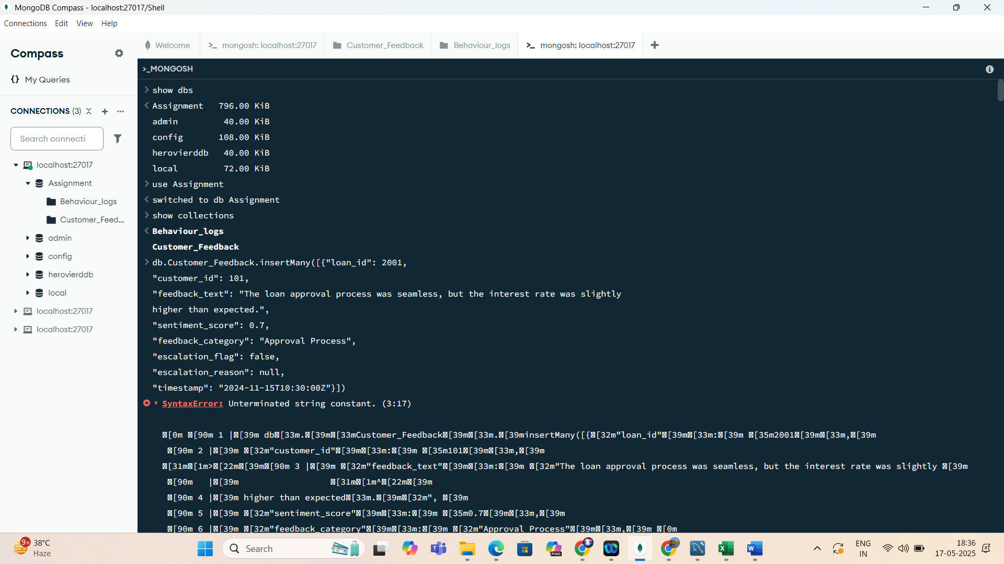

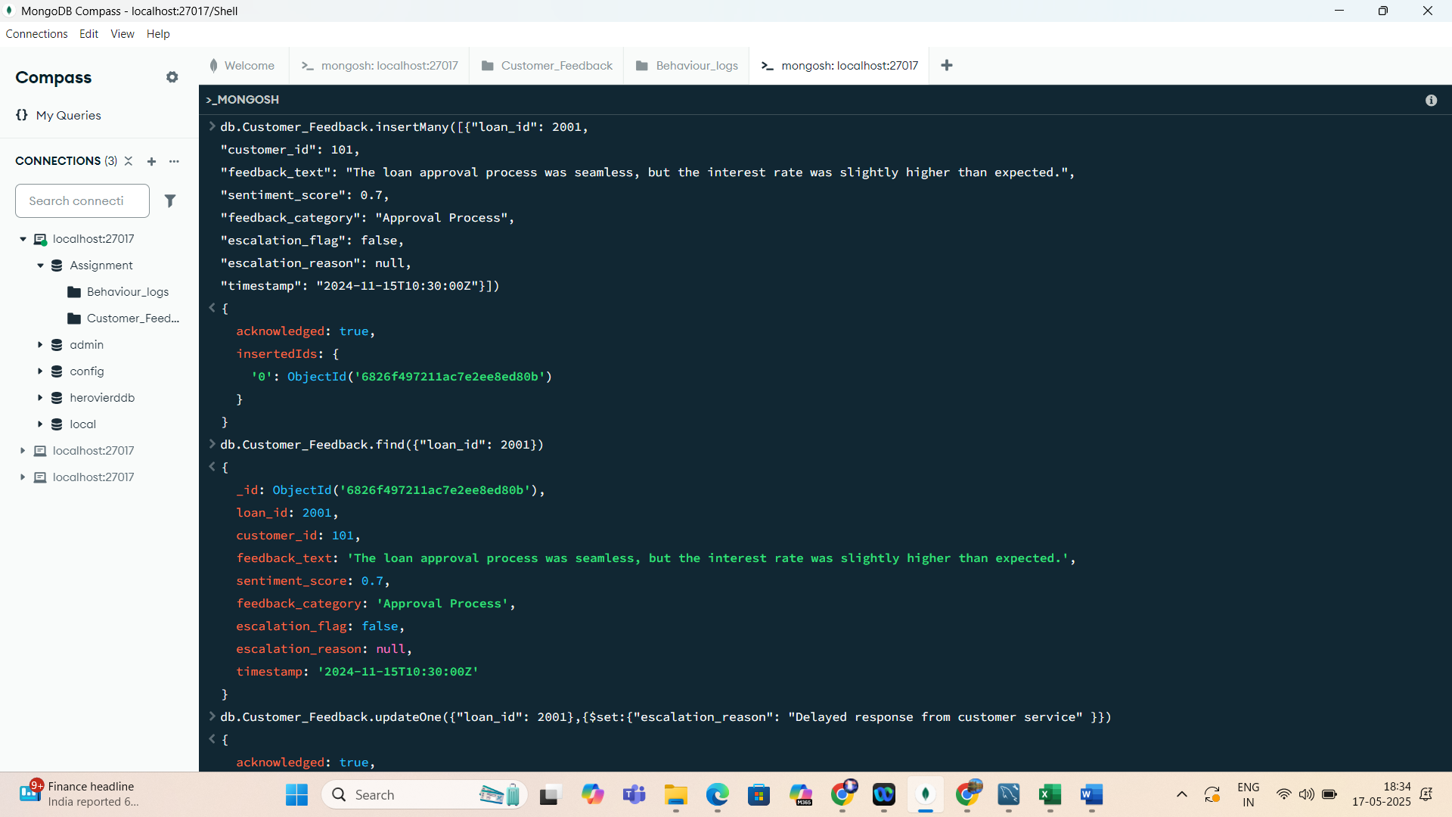

2) Update Escalation Flags. BASIC Input: Update escalation flags in feedback to include specific reasons for unresolved customer complaints.

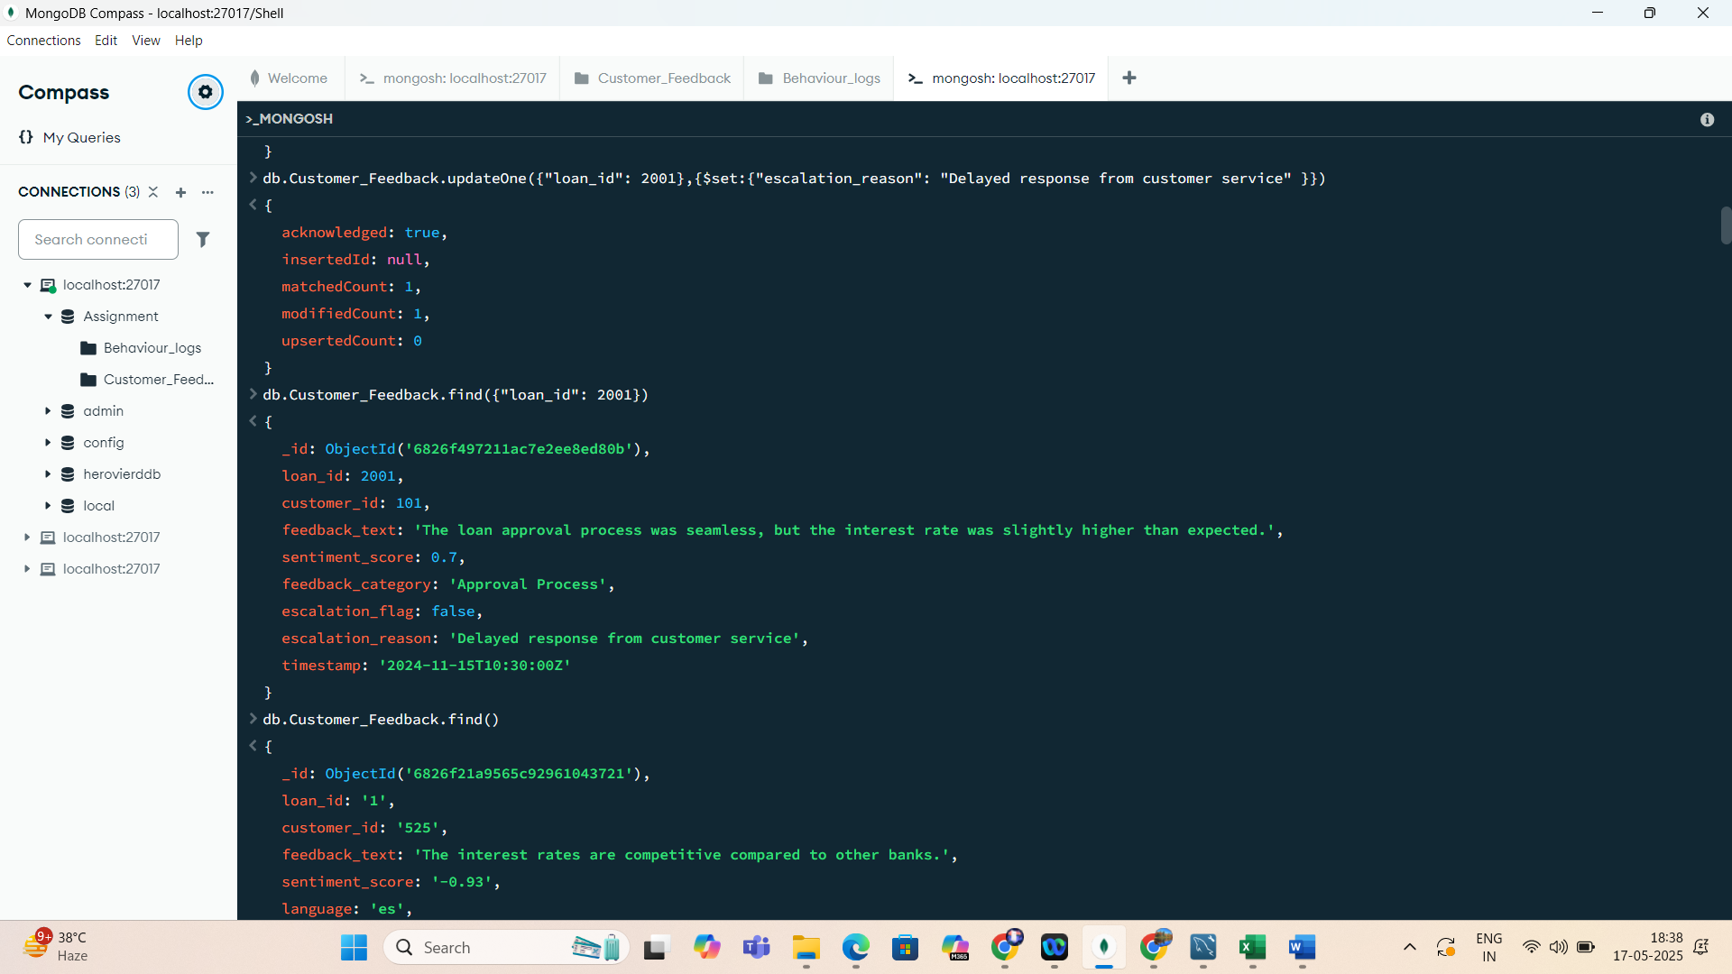

3)3. Remove Duplicate Behavior Logs. BASIC Input: Remove duplicate entries with the same customer_id and timestamp.

4) 4. Retrieve Positive Feedback. BASIC Input: Retrieve feedback entries with sentiment scores greater than 0.5.

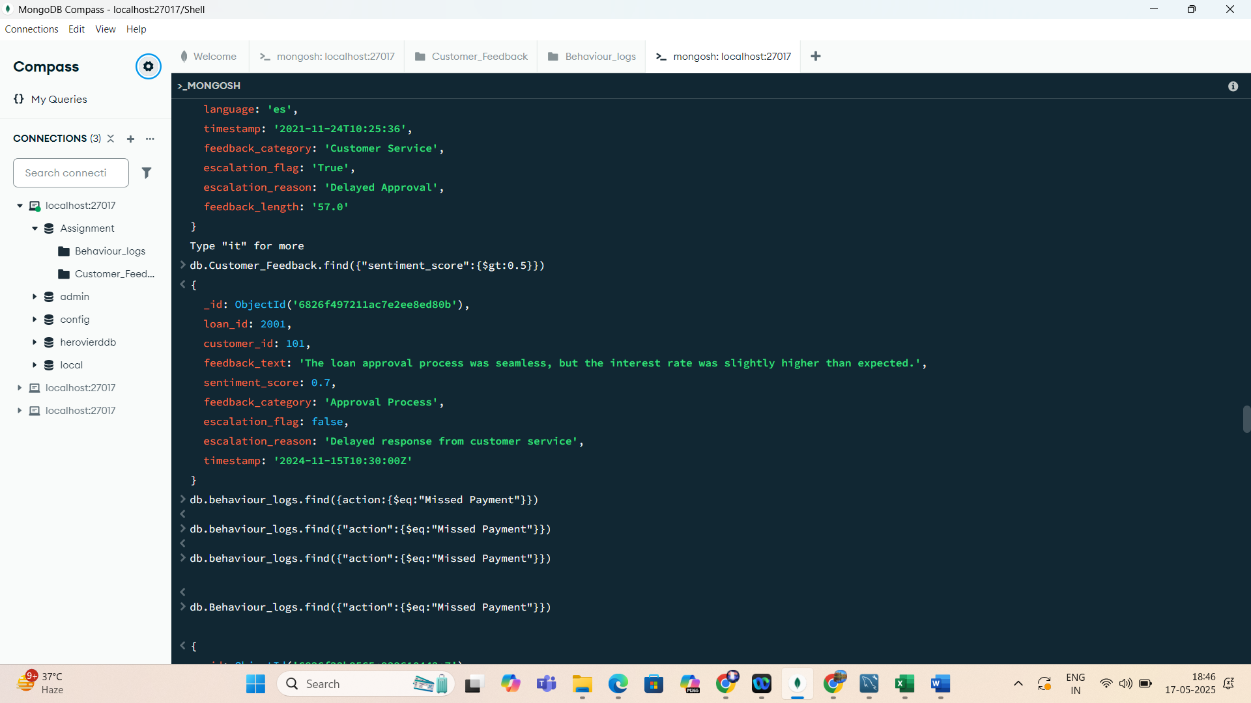

5) Fetch Logs for 'Missed Payment' Actions. BASIC Input: Retrieve behavior logs where the action is "Missed Payment."

